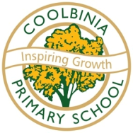
COOLBINIA PRIMARY SCHOOL - Inspiring Growth
Bradford Street – Mt Lawley WA 6050
Telephone: (08) 9444 3798 – Fax: (08) 9444 5553
Email – Coolbinia.PS@education.wa.edu.au
ABN NO: 42 271 610 742
_______________________________________________________________________________

Dear Parents,
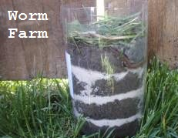
On Thursday 14th June 2018 the students in Pre Primary and Year One are participating in a minibeast incursion to complement their Term Two biological science studies. The students will be learning more about:-
- The environment
- Worm roles in waste management
- Recycling
- Worm biology
- Sustainability
- Gardening

The students also get to make their own mini worm farm to keep!
Please bring in a clean 1.25 or 2 litre plastic bottle before the day (soft drink or water only, milk bottles are not suitable). You will need to cut the necks off the bottles so that they become a cylinder shape, i.e. the kids have to be able to put their hands into the bottles, please see image above.
Kind regards
Rachael McGlinchey, Kathleen Bower, Clare De Felice, Sally Walsh and Cilla Hampton
Coolbinia Primary School

………………………………………………………………………………………......
INCURSION PERMISSION SLIP

I have read and understood the attached information regarding The Wormshed incursion on
Thursday June 14th, 2018.

I give my consent for ________________________ to attend.

Signed: _________________________________ Date: ________________________

Payment
I have paid the $9.00 by: -

Please tick appropriate box regarding payment
At the office
Cash enclosed with the form
Authority to deduct from account
By direct deposit

