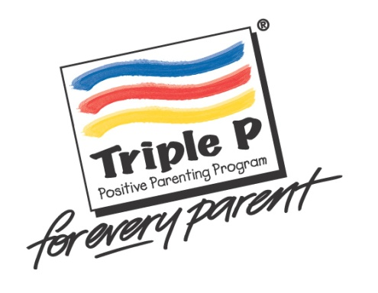

**Triple P Positive Parenting helps you:**

* **raise happy, confident kids**
* **manage kids’ behaviour so everyone enjoys life more**
* **set family rules and routines that everyone follows**
* **get along well with your kids and argue less**
* **balance work and family without stress**

**FREE programs offered by the Department of Health**

* **Seminar Series**
* **Group Triple P**

**All parents, carers and grandparents are welcome to attend.**

**Triple P**

**Positive Parenting Program**

**Next program:**

**Group Triple P commencing Tuesday 8th May 2018**

**5 weekly groups on Tuesday’s: 8th, 15th, 22nd, 29th May, 26th June** plus **3 phone calls.**

**Beatty Park Leisure Centre**

**9:30am - 11:30am**

**Bookings essential –** [**healthywa.wa.gov.au/parentgroups**](http://healthywa.wa.gov.au/Articles/N_R/Parenting-groups)

**Crèche is available - book with centre direct**

